Nama: Aura Aghni Wibowo (251344005)
Haira Aghnia Nurul Faridah (251344008)
Kelas: 1ATNK
Rangkaian Percobaan
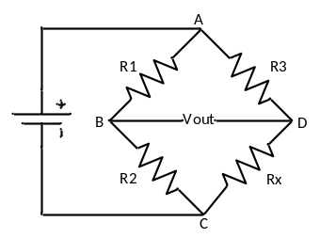
Tabel hasil percobaan
No | R₁(Ω) | R₃(Ω) | R₂ Potensio-meter (terukur (Ω)) | R_{x} (Hasil perhitungan  (Ω)) | R_{x} (Hasil pengukuran  (Ω)) | Error  (%) | R_{x} Warna (TV(Ω)) | V_{DB}  (v)
 | 1k | 1k | 0,97k | 0,97k | 0,97k | 3 | 1k | 1,36
 | 1k | 1k | 1,46k | 1,46k | 1,47k | 2,67 | 1,5k | 0,51
 | 1k | 1k | 1,17k | 1,17k | 1,17k | 2,5 | 1,2k | 0,26
 | 1k | 1k | 2,09k | 2,09k | 2,11k | 5 | 2,2k | 5,61
 | 1k | 1k | 9,73k | 9,73k | 9,90k | 2,7 | 10k | 1,14

Perhitungan R_{x}
- $R_{x}=\frac{R_{2}R_{3}}{R_{1}}=\frac{1k×0,97k}{1k}=0,97k$
- $R_{x}=\frac{R_{2}R_{3}}{R_{1}}=\frac{1k×1,46k}{1k}=1,46k$
- $R_{x}=\frac{R_{2}R_{3}}{R_{1}}=\frac{1k×1,17k}{1k}=1,17k$
- $R_{x}=\frac{R_{2}R_{3}}{R_{1}}=\frac{1k×2,09k}{1k}=2,09k$
- $R_{x}=\frac{R_{2}R_{3}}{R_{1}}=\frac{1k×9,73k}{1k}=9,73k$
Perhitungan Error
- $\%error=\left|\frac{TV warna-TV R_{x}}{TV warna}\right|=\left|\frac{1-0,97}{1}\right|×100\%=3\%$
- $\%error=\left|\frac{TV warna-TV R_{x}}{TV warna}\right|=\left|\frac{1,5-1,46}{1,5}\right|×100\%=2,67\%$
- $\%error=\left|\frac{TV warna-TV R_{x}}{TV warna}\right|=\left|\frac{1,2-1,17}{1,2}\right|×100\%=2,5\%$
- $\%error=\left|\frac{TV warna-TV R_{x}}{TV warna}\right|=\left|\frac{2,2-2,09}{2,2}\right|×100\%=5\%$
- $\%error=\left|\frac{TV warna-TV R_{x}}{TV warna}\right|=\left|\frac{10-9,73}{10}\right|×100\%=2,7\%$

Nama: Aura Aghni Wibowo (251344005)
Haira Aghnia Nurul Faridah (251344008)
Kelas: 1ATNK
Rangkaian Percobaan
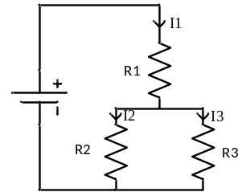
Tabel hasil percobaan
No | R(Ω) | I teori (TV(A)) | I pengkuran (MV(A)) | Error(%)
 | 3,3k | $$I_{1}= \frac{V_{S}}{R_{total}}=\frac{5,1}{4,192}=1,217mA$$ | 1,20mA | $$1,397$$
 | 1,5k | $I_{2}= \frac{R_{3}}{R_{2}{+R}_{3}}×I_{1}=\frac{2,2}{1,5+2,2}×1,217=0,724mA$ | 0,70mA | $$3,315$$
 | 2,2k | $I_{3}= \frac{R_{2}}{R_{2}{+R}_{3}}×I_{1}=\frac{1,5}{1,5+2,2}×1,217=0,493mA$ | 0,48mA | $$2,637$$
$$R_{total}=R₁+\frac{R_{2}{×R}_{3}}{R_{2}{+R}_{3}}=3,3+\frac{1,5×2,2}{1,5+2,2}=4,192kΩ$$
Perhitungan Error
- $\%error=\left|\frac{TV-MV}{TV}\right|=\left|\frac{1,217-1,20}{1,217}\right|×100\%=1,397\%$
- $\%error=\left|\frac{TV-MV}{TV}\right|=\left|\frac{0,724-,070}{0,724}\right|×100\%=3,315\%$
- $\%error=\left|\frac{TV-MV}{TV}\right|=\left|\frac{0,493-0,48}{0,493}\right|×100\%=2,637\%$

